Eyeconic - Glasses Shop Management System

Storage Box

Version <1.0>

Revision History

|  |  |  |  |
| --- | --- | --- | --- |
| **Date** | **Version** | **Description** | **Author** |
| 04/11/2019 | 1.0 | The first version of edit Storage Box | Nguyễn Tuấn Anh |

Table of Contents

1. Introduction 4

1.1 Purpose 4

1.2 Scope 4

1.3 Definitions, Acronyms, and Abbreviations 4

1.4 References 4

1.5 Overview 4

2. Flow of Events—Design 4

3. Derived Requirements 6

# Introduction

## Purpose

This document describes how the Edit Storage Box use case is realized within the design model.

## Scope

This document applies to the Eyeconic - Glasses Shop Management System.

## Definitions, Acronyms, and Abbreviations

None.

## References

None.

## Overview

In the following section, Use-Case Realization Specification of the Edit Storage Box use-case of the Eyeconic is provided in detail. The first section is a textual description of the Use-Case specification. The following section contains sequence diagrams describing how the use case is realized in terms of collaborating objects. The third section includes class diagrams with relationships that participate in the realization of the use case. The last section is an analysis of all requirements, such as non-functional requirements, on the use-case realization that are not considered in the design model, but that need to be taken care of during implementation.

# Flow of Events—Design

**2.1. Use-Case Specification**

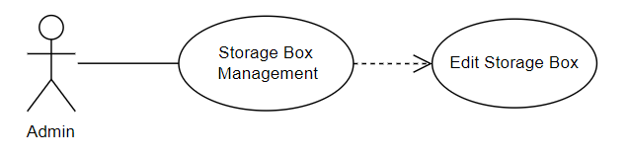

|  |  |  |  |
| --- | --- | --- | --- |
| **Name** | | | Edit Storage Box |
| **Brief Description** | | | Administrator edits new Storage Boxes into the website. |
| **Actors** | | | Administrator |
| **Flow of Events** | | | |
| **Basic Flow** | | | |
| Step 1: Click edit a new Storage Box button in Storage Box management.  Step 2: Fill changing Storage Box’s information.  Step 3: Set the database parameters of edited Storage Box.  Step 4: System displays edited Storage Box in the website. | | | |
| **Alternative Flows** | | | |
| **Title** | | **Description** | |
| Invalid information entered | | 1. Administrator enters invalid information.  2. System displays information with appropriate message to correct invalid information. | |
| **Pre-Conditions** | | | |
| The edited Storage Box had not existed in the database before. | | | |
| **Post-Condition**  Administrator checks the database and the website to ensure that the new Storage Box is edited successfully. | | | |
| **Title** | **Description** | | |
| Success | Success message is prompted and the Storage Box is edited to database. | | |
| Failure | The admin is unable to edit new Storage Box to database for one or more reasons and an error is prompt. | | |
| **Extension Points** | None | | |

**2.2. Sequence Diagram**

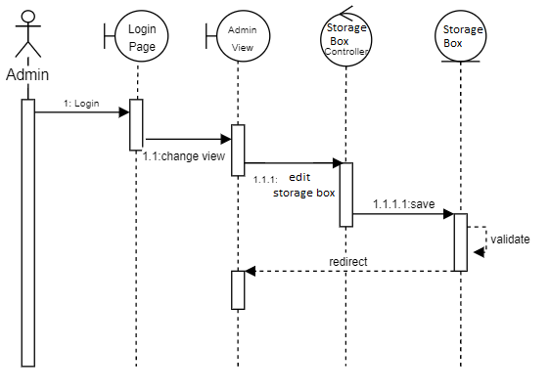

**2.3. Class Diagram**

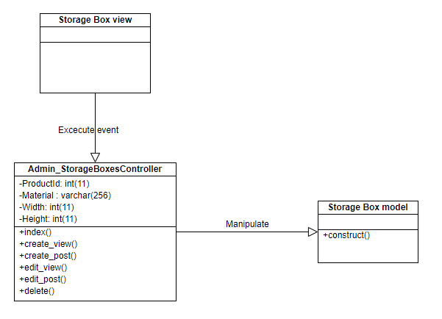

# Derived Requirements

None.